**IBM ASSIGNMENT – 1**

**(SUBMITTED BY: Gowthaman K)**

**Circuit with Piezo alarm, PIR sensor, Temperature sensor with below functionalities:**

1. Alarm sound if temperature is above 60℃.
2. Alarm sound with different frequency if motion is detected in PIR sensor.

**Circuit :**

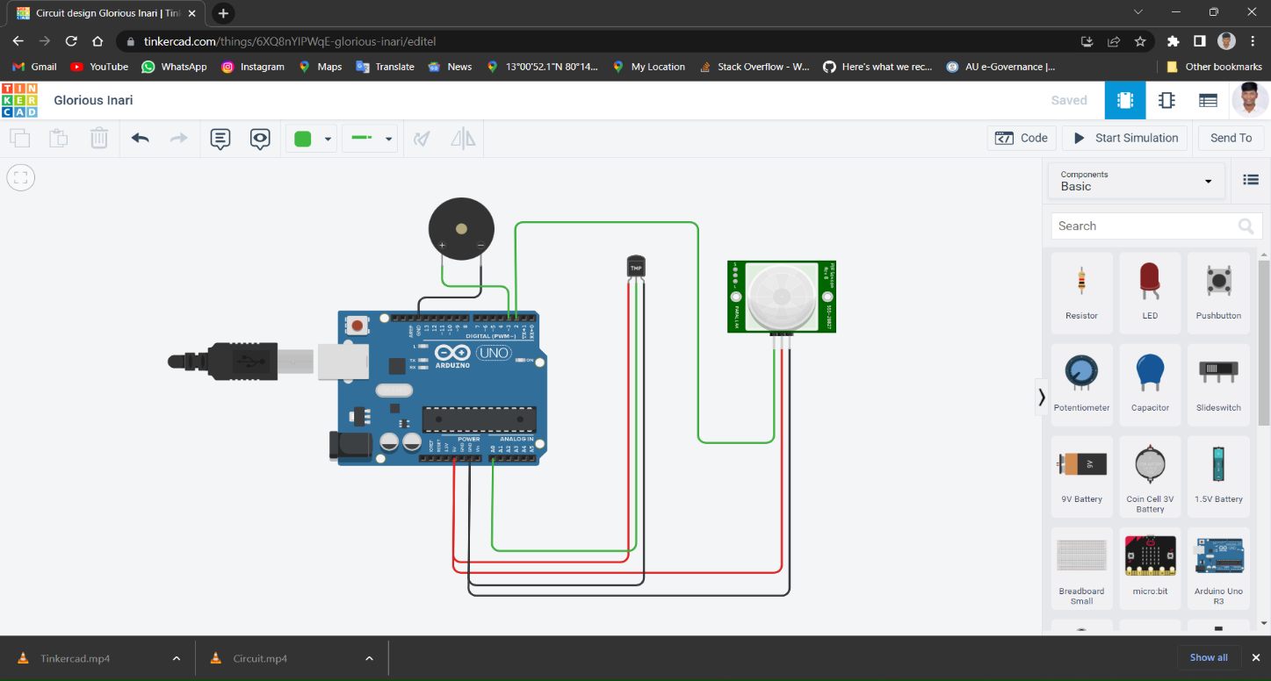

**Code :**

void setup()

{

Serial.begin(9600);

pinMode(2,INPUT);

pinMode(A0,INPUT);

pinMode(3,OUTPUT);

}

void loop()

{

int motion= digitalRead(2);

if (motion==1)

{

Serial.println("MOTION DETECTED");

}

else

{

Serial.println("NO MOTION DETECTED");

}

double data=analogRead(A0);

double n=data/1024;

double volt=n*5;

double off=volt-0.5;

double temp=off*100;

Serial.print("Temperature is : ");

Serial.println(temp);

if(motion==1)

{

tone(3,1000);

delay(1000);

}

else if(temp>=60)

{

tone(3,200);

delay(1000);

}

else

{

noTone(3);

delay(1000);

}

}

**Output :**

